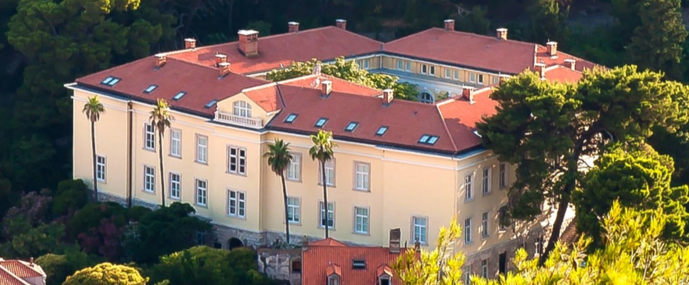

Call for participation: 9th Graduate Spring School & Research conference on Comparative Media Systems “Comparing Post-socialist Media Systems”, Interuniversity Center (IUC) Dubrovnik, 14-19 April 2020
Co-organized with the ECREA CEE Network
Course directors and lecturers:
Zrinjka Peruško, University of Zagreb, Croatia
Carmen Ciller, Universidad Carlos III de Madrid, Spain
Steffen Lepa, Technische Universität Berlin, Germany
Paolo Mancini, Università di Perugia, Italy
Snježana Milivojević, University of Belgrade, Serbia
Slavko Splichal, University of Ljubljana, Slovenia
Miklós Sükösd, University of Copenhagen, Denmark
This year’s lecturers also include:
- Laia Castro Herrero, Department of Media and Communication Research, University of Zurich
- Epp Lauk, Department of Communication, University of Jyvaskyla,
- Helmut Scherer, Institut für Journalistik und Kommunikationsforschung of the Hochschule für Musik, Theater und Medien Hannover
- Miklós Sükösd, University of Copenhagen, Denmark
- Lenka Vochocová, Department of Media Studies, Charles University, Prague
- Dina Vozab, Department of Media and Communication, University of Zagreb
In Central and Eastern Europe it is 30 years since the socialist regimes collapsed, and democracy was introduced. The theoretical framework of the “transition” is no longer employed, even the “consolidation” discourse and approach is over. The thirty years of transformation have been diverse. The same original critical juncture of the fall of socialism has been differently used and shaped by different actors, countries or institutions, to produce different results. Not only is there a division of CEE into those who are now members of the EU and those who are not, but there is also a division between those who have consolidated some level of democracy and those who have consolidated some degree of authoritarian regimes. The authoritarian backsliding is a fact that can no longer be treated as a phase in the consolidation of democracy, but must also be recognized as one type of result of the transformations. Can we say that the media systems in this region of the world have acquired a settled shape, a form/character that is durable and stable? Will a new critical juncture will be necessary in order to re-start developments along the road to consolidated democracy and democratic media systems development?
What shaped these diverse developments? Why did some countries consolidate democracy and free media systems, and others have hybrid or authoritarian regimes with captured media? How do these changes compare to the changes of other European media systems? Should we compare media systems or media cultures? We will in this course and research conference examine conditions and variables of media change from modernization to socialism, and from socialism to post-socialism. We will explore ways to study change in media systems, focusing both on the temporal and spatial frames, and will examine transformations necessary in the political, economic and cultural fields. And we will examine which combination of historical conditions from the longue durée or more recently are responsible for certain types of outcomes of media systems. The focus of the course & research conference will extend also to different media related and journalistic practices in the region in focus.
A one day methodological hands-on workshop on fsQCA will be a part of the program.
This 9th "slow science" IUC-CMS is an interdisciplinary research conference & post-graduate course open to academics, doctoral and post-doctoral students in media, communication and related fields engaged with the issue of media and media systems, that wish to discuss their current work with established and emerging scholars and get relevant feedback.
Invited research conference participants will deliver keynote lectures with ample discussion opportunities. In this unique academic format, student course attendees will have extended opportunity to present and discuss their current own work with the course directors and other lecturers and participants in seminar form (English language) and in further informal meetings around the beautiful old-town of Dubrovnik (UNESCO World Heritage) over 5 full working days (Tuesday to Saturday).
The working language is English.
Participation in the course for graduate (master and doctoral) students brings 3,5 ECTS credits, and for doctoral students who present their thesis research 6 ECTS. The course is accredited and the ECTS are awarded by the Faculty of Political Science, University of Zagreb (www.fpzg.unizg.hr). All participants will also receive a certificate of attendance from the IUC.
Enrolment
To apply, send a CV and a motivation letter to zperusko@fpzg.hr. Students who wish to present their research should also send a 300 word abstract. The course can accept 20 students, and the applications are received on a rolling basis. After notification of acceptance you need to register also on this web page https://www.iuc.hr/course-details.php?id=1206
The IUC requires a small enrolment fee from student participants. Participants are responsible for organizing their own lodging and travel. Affordable housing is available for IUC participants. Stipends are available from IUC for eligible participants, further information at https://www.iuc.hr/iuc-support.php. For information on these matters please contact the IUC secretariat at iuc@iuc.hr.
Venue Information
The Inter-University Centre was founded in Dubrovnik in 1972 as an independent, autonomous academic institution with the aim of promoting international co-operation between academic institutions throughout the world. Courses are held in all scientific disciplines around the year, with participation of member and affiliated universities.
Additional Information
For further information about academic matters please contact the organizing course director: professor Zrinjka Peruško zrinjka.perusko@gmail.com, Centre for Media and Communication Research (www.cim.fpzg.unizg.hr), Department of Media and Communication, Faculty of Political Science (www.fpzg.unizg.hr), University of Zagreb (www.unizg.hr).

